English

Press release - BrandCharger® and SKROSS® exclusive partnership
June 29, 2017
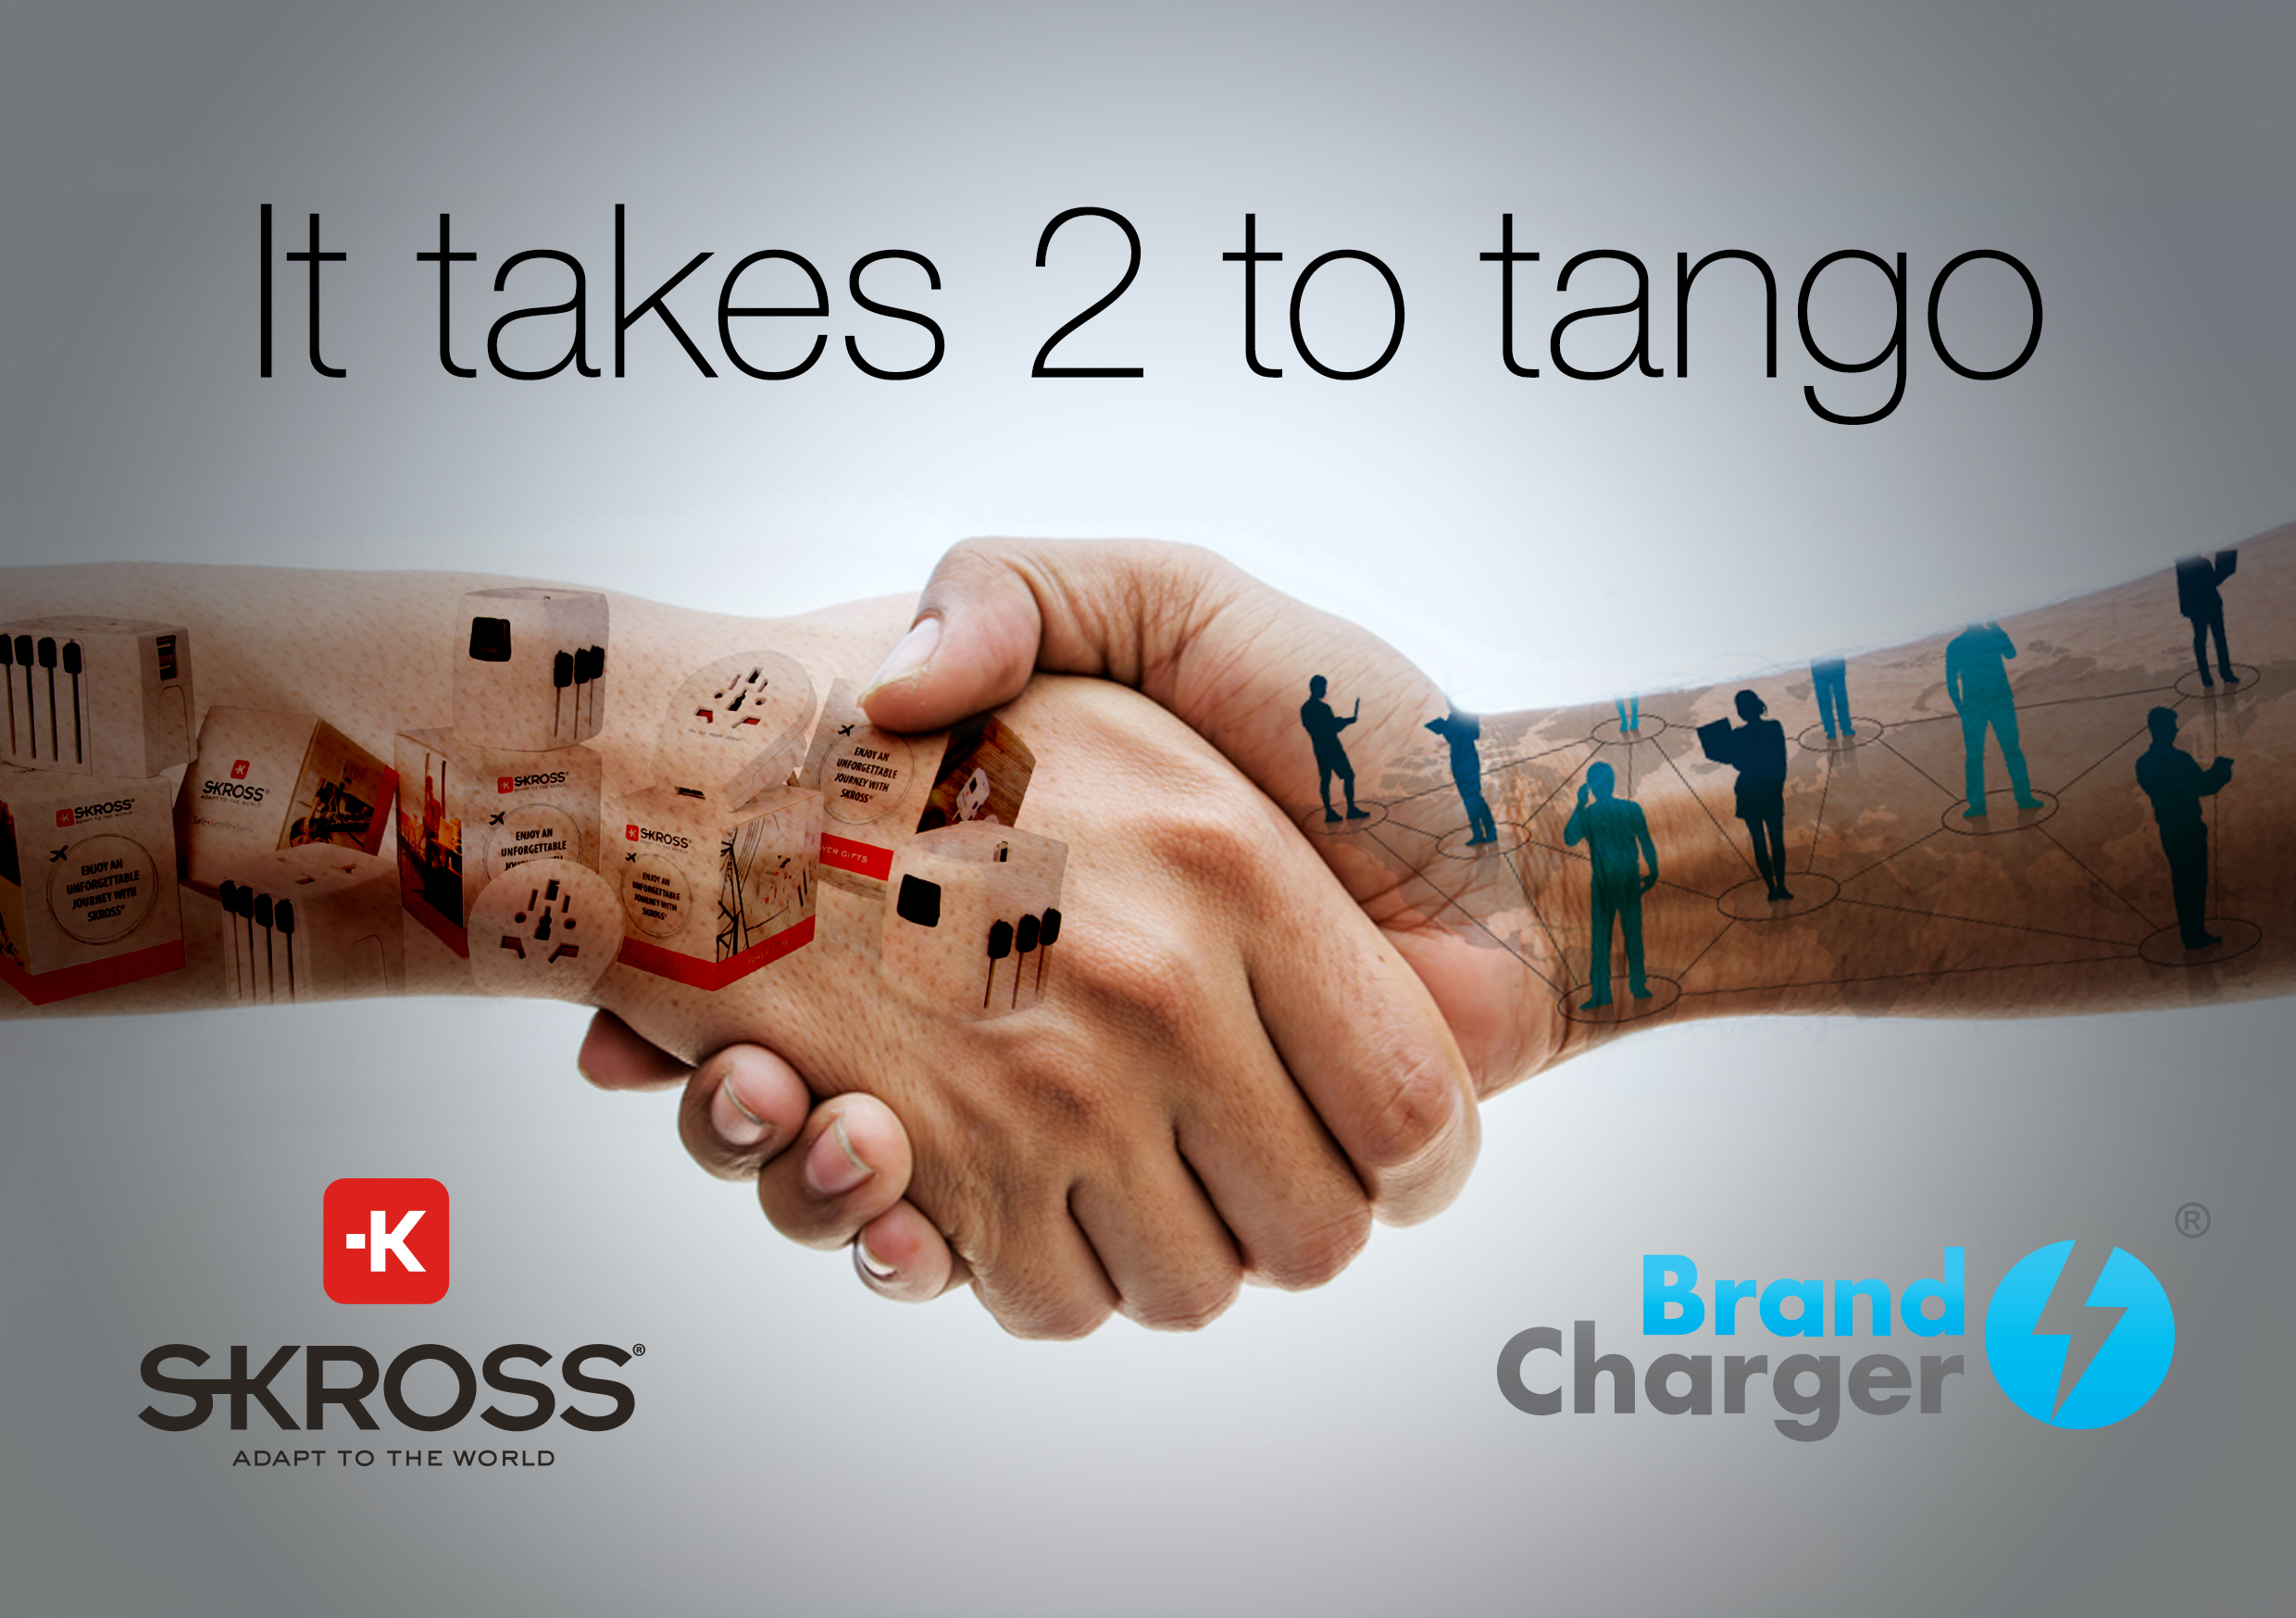
BrandCharger® and SKROSS® have started a partnership, bringing 2 worlds together; award winning corporate gifts and Swiss-designed travel adapters.
BrandCharger will be supplying SKROSS® products almost worldwide and exclusively in Asia and the Middle East for the corporate gift industry. Operating with stock in The United States, Austria, Middle East and China (Hong Kong / Shenzhen).

This partnership is certainly an important step for BrandCharger, with a strong aim to grow in the corporate gift industry, providing high quality safe products to our customers worldwide.
The additions of the SKROSS line of products will surely help us enrich and enhance our existing product offerings. This will strengthen our position in being a market leader for USB charging devices and with 17 industry awards in the pocket, BrandCharger is ready for the future.
“BrandCharger® + SKROSS®” is a partnership between two global players with a shared passion for creating meaningful products. Through BrandCharger’s focus is on tech products and SKROSS®’ is on developing high-quality renowned travel adapters, a strong partnership has been crafted,” said James Ung, BrandCharger’s President. “We are working with SKROSS® to take connectivity to a whole new level.”

SKROSS® operates in over 100 countries around the world, successfully positioning itself as the leading brand in the field of high-quality travel accessories. SKROSS® travel adapters speak all languages of electricity and keep you connected all over the world with its patented country slider system.

At SKROSS®, safety is always at the centre of the entire development and production process. The standards defined by the International Electrotechnical Commission (IEC) form the foundation of SKROSS® products that give you access to power anywhere in the world. At the same time, SKROSS® products remain the most compact and easy to use on the market. That is what makes SKROSS® unique.

For more information please contact:

James Ung Alina Lytvynenko
BrandCharger WorldConnect AG (SKROSS)
T: +852 54100411 T: +41 717379764
E: james@brandcharger.asia E: lyal@worldconnect.ch

