English

Press release
May 12 2016

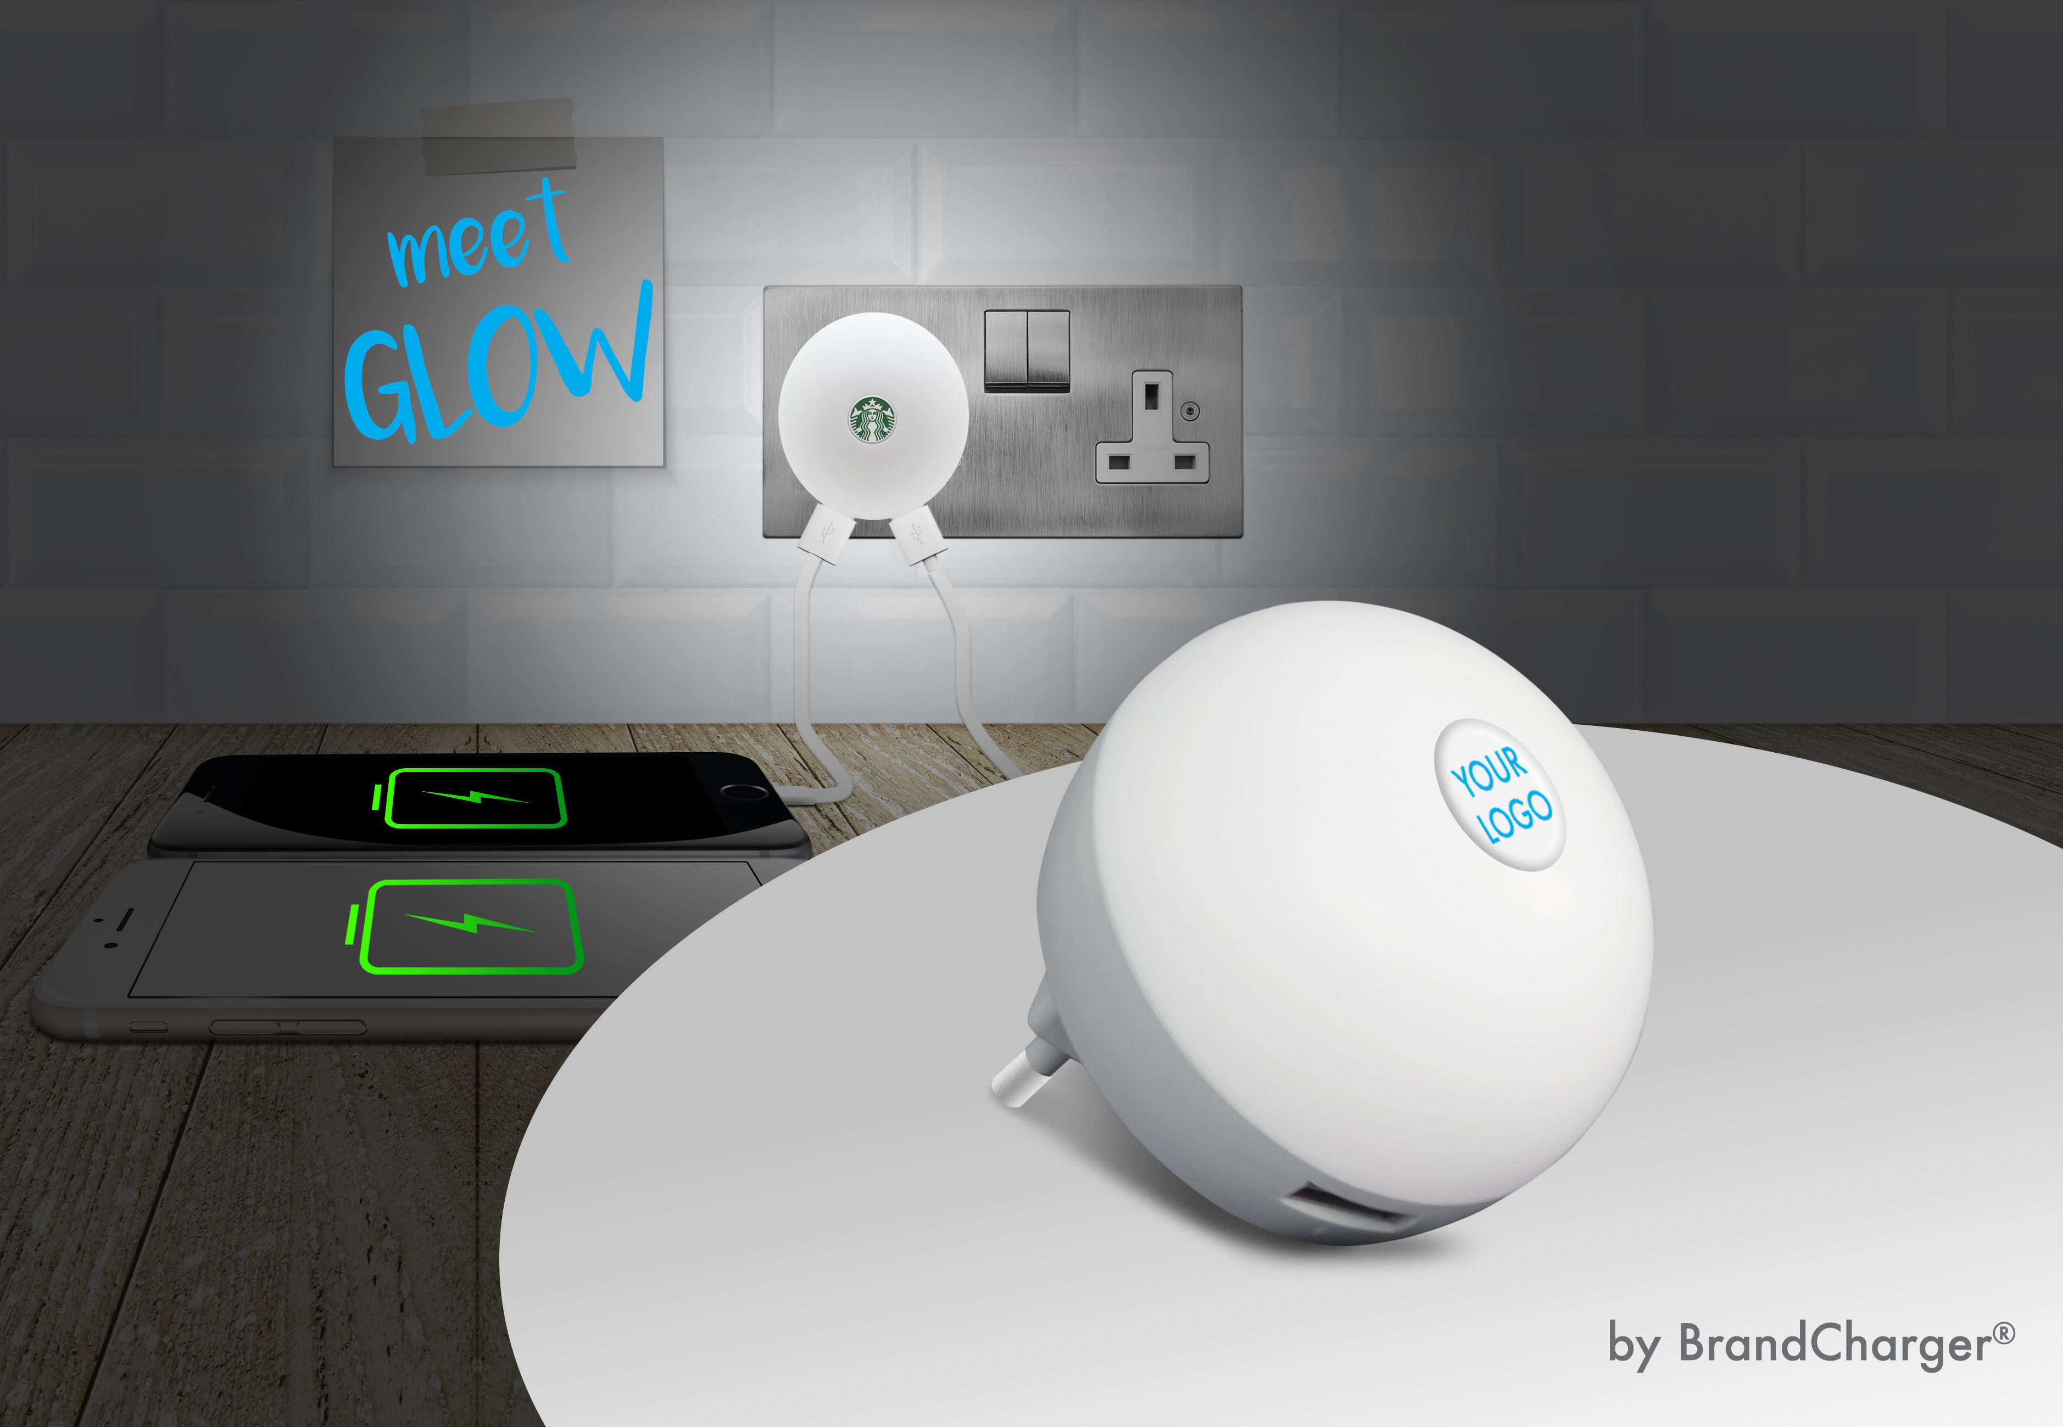

BrandCharger expands its lifestyle products with “Glow”

BrandCharger is know for it’s tech gadgets, and now we are making a foray into the world of LED lightning with “Glow”, simply because life should be fun.

Glow is a dual port USB wall charger combined with a comfortable night light function, available with the US, EU or UK wall plug. It is hard to imagine living without USB devices nowadays. Whether a smartphone, tablet or e-book reader, USB powered devices have become permanent fixtures in every household. Glow is the definitive solution to keep you charged combined with a comfortable night light as well.
Now that’s a bright idea!

Safety
Glow is made of fire retardant materials and has all safety features built-in.
For all BrandCharger products, the observance of international relevant safety standards is at the foreground during the entire development and production process. This is what makes the significant difference between BrandCharger and its competitors.

Glow is available from mid May 2016

About BrandCharger
BrandCharger creates unique charging and electronic products for the corporate gift market. Our recipe for that is a proper understanding of branding and functionality mixed with design skills.

With a strong line-up of charging products, 13 industry awards, being the market leader for USB charging devices we bring safe and high quality products to consumers at a rate of over 1.5 million units a year. We are committed to making sure all of the thousands of products per week we produce meet the highest safety and quality standards.

For more information please contact:
James Ung
President
T: +852 54100411
E: james@brandcharger.asia
W. www.brandcharger.com

PSI #48361
PPA # 51411
PSI # 48361
SAGE # 69300
UPIC # BCR

